|  |  |
| --- | --- |
| MEDIA RELEASE |  |

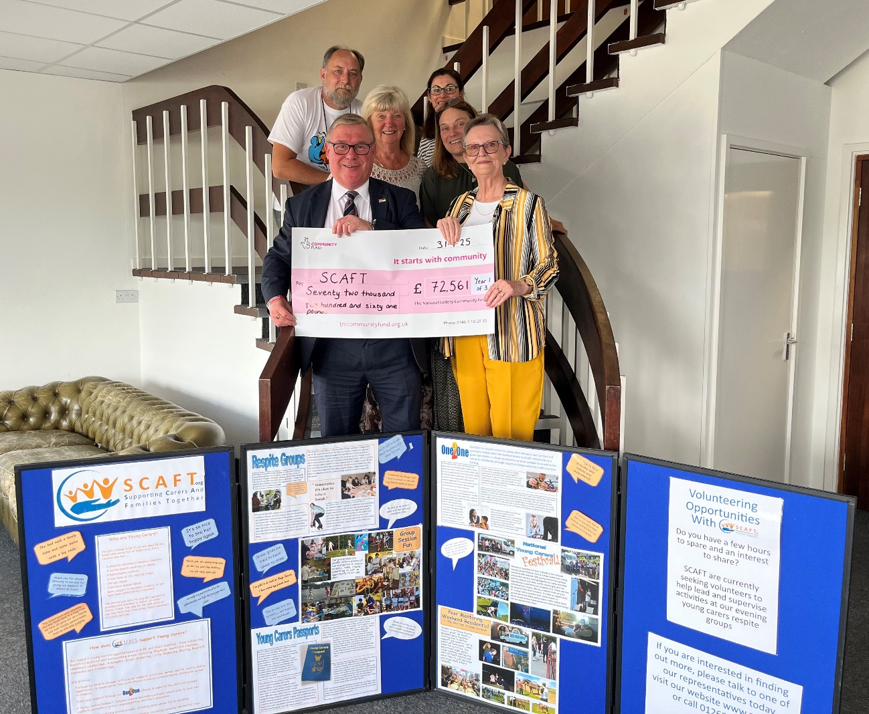The staff and Trustees of local charity Supporting Carers And Families Together were pleased to welcome Honorary President, the Rt Hon Mark Francois MP, to their office on Monday morning (21st July), to present a cheque from The National Lottery Community Fund. This grant will help towards supporting young carers aged 6-18, from across the Rochford District, who help care for a family member. Service Delivery Manager Andrew Trewern said, ‘this grant will make a real difference to local young carers, ensuring they continue to receive vitally needed support’. SCAFT, who celebrated their 15th Anniversary last year, provide a range of group and individual services to these amazing children and young people, who face daily challenges at home, whilst also trying to successfully engage with their education. Mark has keen personal interest in young carers and during the visit discussed the challenges facing both them and the charities supporting them, in the face of steadily falling corporate and personal donations and rising demand.

Permission is granted by SCAFT for the use of both the text and photographic content within this release for publication in print and online.